

|  |
| --- |
| IIS 7 Web Policy Agent Installation |
|  |
| December 4, 2015 |
|  |

Contents

IIS 7 Web Policy Agent Installation 1

1 Objective 3

2 Required Software 3

3 Prerequisites 3

4 Introduction 3

5 Installing IIS 7 Web policy Agent 3

6 Goto OpenAM Console, Login as Admin > 4

7 To Create Password File: Create a text file containing only the password. 5

8 OpenAM configuration settings: 5

9 To Configure Policy Agent Installation: 7

10 Application Pool settings 10

11 To uninstall the agent 13

# Objective

To provide detailed steps to Install .Net IIS7 Web Policy Agent Installation on IIS Server.

# Required Software

|  |  |
| --- | --- |
| **Software** | **Release** |
| IIS Web Agent | 7 and Above |
| Web Server | Microsoft IIS, Version 7 & above, OS 64 Bit |
| JAVA | JAVA 1.7.0 |

# Prerequisites

* Download Microsoft IIS 7 Web Policy Agent from https://backstage.forgerock.com/#!/downloads.
* Java Development Kit
* An IIS Web Server with Version 7 & above with OS architecture 64-Bit.
* .Net application

# Introduction

OpenAM web policy agents provide light touch integration for web applications running on supported web servers. This document is written for anyone installing OpenAM .Net Web policy agents to interface with supported web server’s application containers. It covers procedures that you theoretically perform. This document aims to provide you with at least some idea of what happens behind the scenes when you perform the steps.

# Installing IIS 7 Web policy Agent

Complete the following procedures to install the policy agent.

To Create the IIS7 Web Agent Profile:

Regardless of whether you store configurations centrally in OpenAM or locally with your agents, the agent requires a profile so that it can connect to and communicate with OpenAM.

# Goto OpenAM Console, Login as Admin >

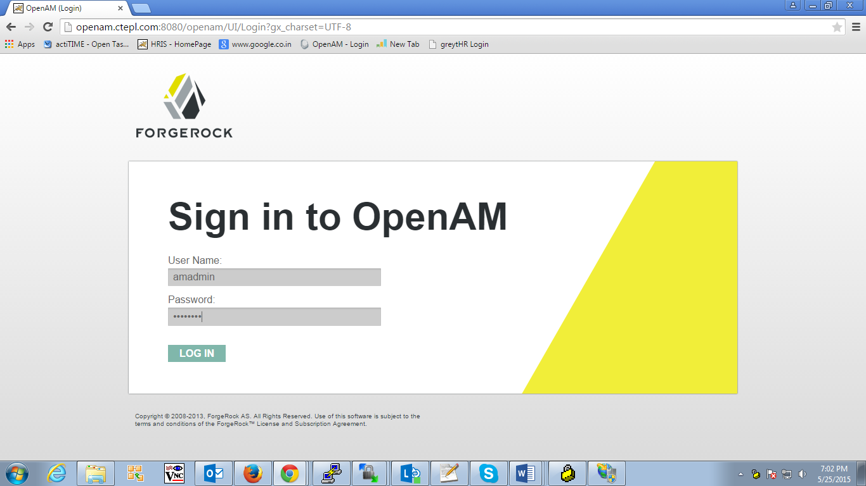

* browse to Access control > Realm(Top Level realm is default) > Agents > Web and then click new.. button in the agent table.
* Complete the form with hints like..
* Name: Name of the agent profile which you want to install
* Password: Password the agent uses to authenticate to OpenAM.
* Configuration: Centralized configurations are stored in the OpenAM configuration store. You can manage the centralized configuration through the OpenAM console.
* Server URL: The full URL to an OpenAM instance, or if OpenAM is deployed in a site configuration (behind a load balancer) then the site URL.
* Agent URL: The web server URL that the agent protects.

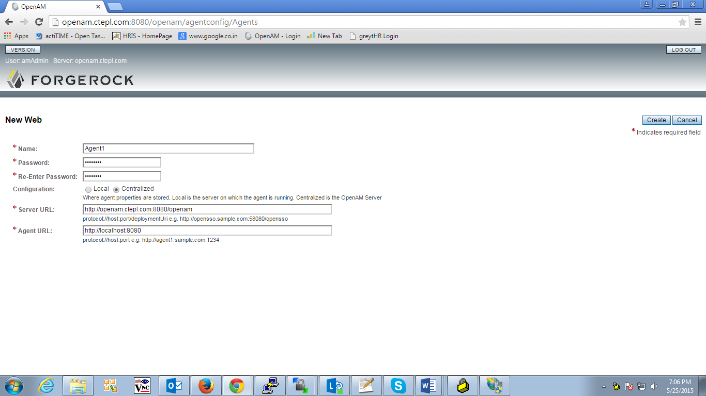

# To Create Password File: Create a text file containing only the password.

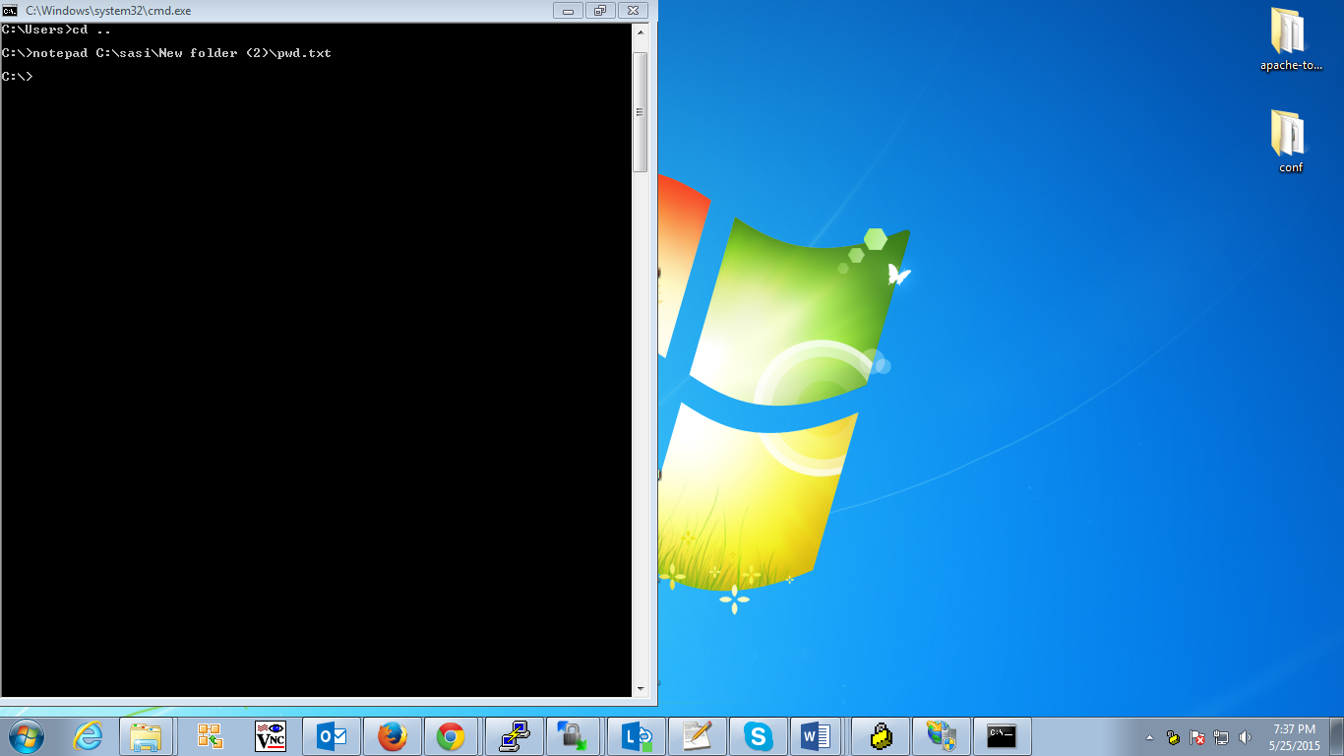

# OpenAM configuration settings:

Browse to Access control > Realm(Top Level realm is default) > Agents > Agent1 profile > Global > check the SSO only mode to enabled > save the agent profile.

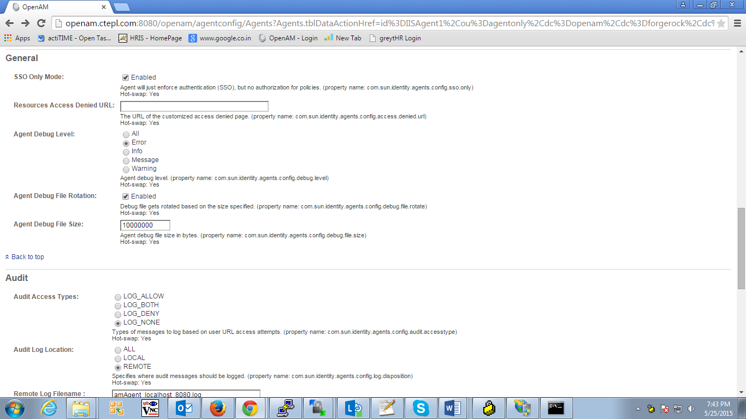

Browse to Access control > Realm(Top Level realm is default) > Agents > Agent1 profile > Application > Profile Attribute processing > select radio button of Profile Attribute Fetch Mode to HTTP_HEADER and

Add the Profile Attribute Map uid=UID & mail=EMAIL

Save the changes made in the page.

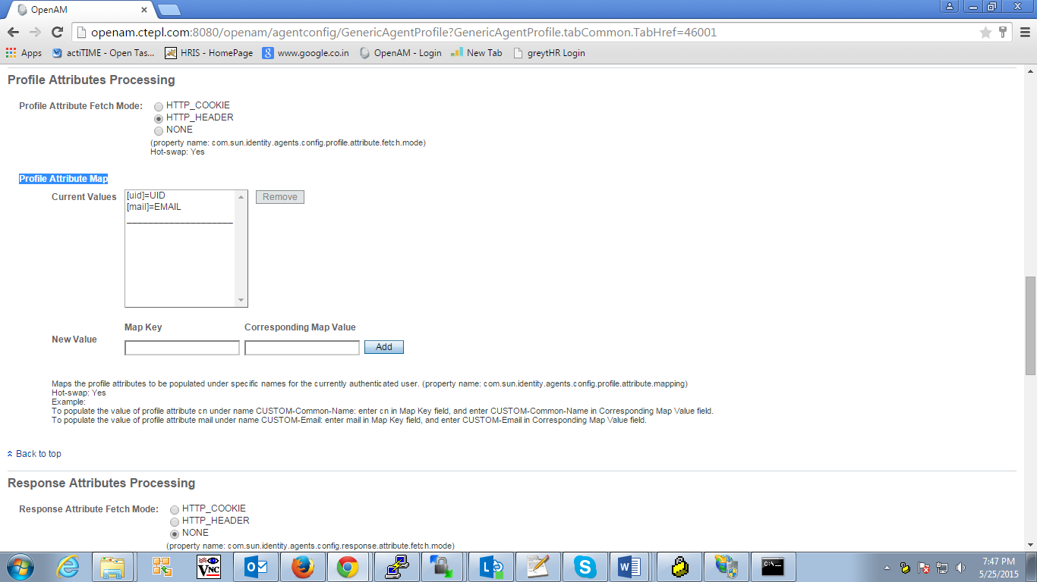

# To Configure Policy Agent Installation:

* Log on as a user with Administrator privileges.
* Change to the directory where you unpacked the agent download.

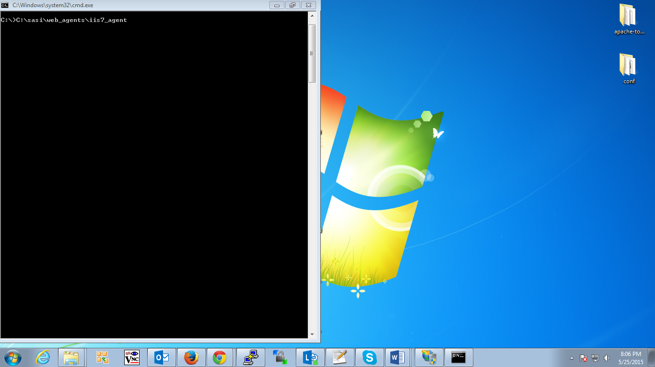

* Create a configuration file using the IIS7CreateConfig.vbs script
* Execute IIS7CreateConfig.vbs  
    
  C:\IIS-v7-WINNT-64-Agent-3.3.3\web_agents\iis7_agent\bin>cscript IIS7CreateConfig.vbs config.txt
* Press enter to the following prompt.  
    
  Enter the Agent Resource File Name [IIS7Resource.en] :
* Enter the agent url on following prompt.  
    
  Enter the Agent URL (Example: <http://agent.example.com:80>) : <https://requestweb1.am.recall.com:443>

NOTE: Above URL is for demonstration purpose only. Please use FQDN in the url.

* Next prompt is for default website press 1 and enter.

Displaying the list of Web Sites and its corresponding Identifiers (id) SITE

"Default Web Site" (id:1,bindings:http/*:80:,state:Started) Web Site Identifier :1

* Enter <https://openam.qa.recall.com:443/openam> on next prompt  
  ...  
  Enter the URL where the OpenAM server is running...: <https://openam.recall.com:443/openam>
* Agent profile name is RequestWeb   
    
  Please enter the Agent Profile name : RequestWeb

NOTE: Agent profile is for demonstration purpose only. Please use the profile name which was used while create the Agent profile.

* Enter the agent profile password in next step which you saved in 3.3.1 agent's folder   
    
  Enter the Agent profile password file : c:\IIS-v7-WINNT-64-Agent-3.3.3\web_agents\iis7_agent \pass.txt  
    
    
  -----------------------------------------------------  
  Agent Configuration file created : config.txt  
  -----------------------------------------------------
* Below Screenshot for ref :
* 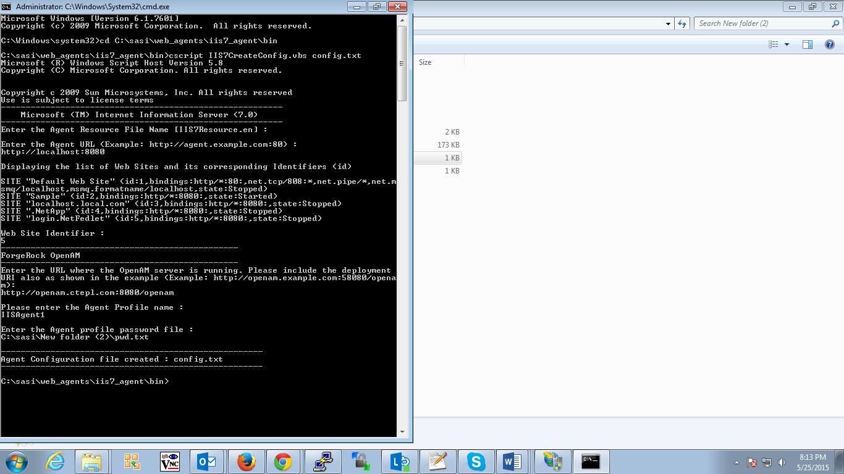

Install the agent

* Log on the user with administrators privilages.
* Make sure OpenAM is running.
* Run IIS7Admin.vbs to install the agent.
* Install OpenAM 3.3.3 policy agent for IIS
* Cd c:\IIS-v7-WINNT-64-Agent-3.3.3web_agents\iis7_agent\bin
* Execute cscript IIS7Admin.vbs -config config.txt
* Note: [Hit Enter] when you see "Enter the Agent Resource File Name [IIS7Resource.en]
* Restart IIS with iisreset
* Below Screenshot for ref :

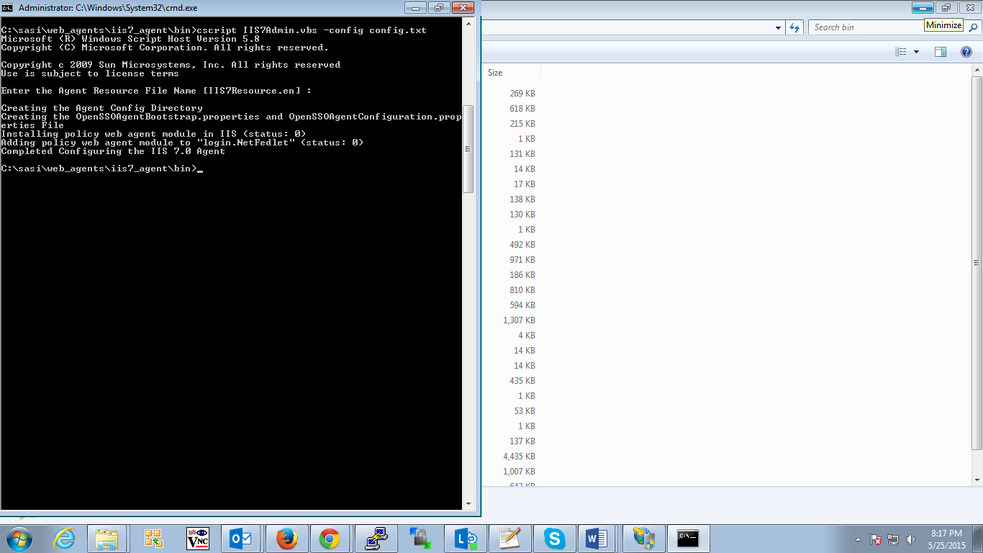

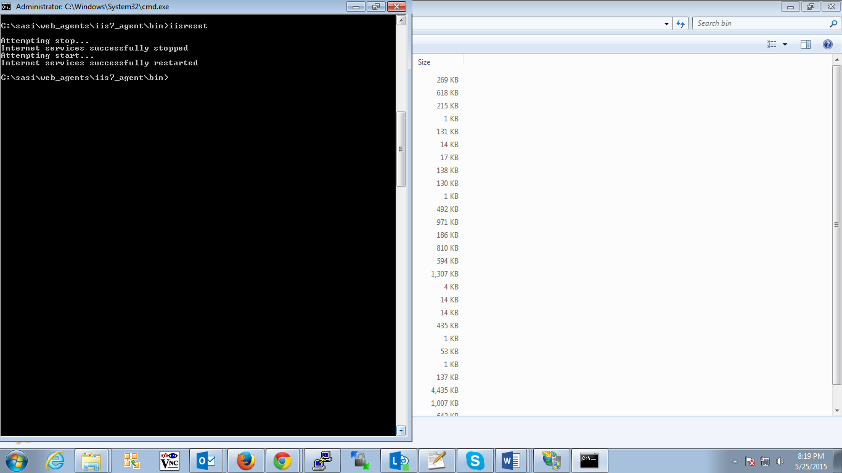

# Application Pool settings

Following Application Pool settings needs to be made for both DefaultAppPool and Recall

Open Inet Manager Screen

In Connections window select Application pool

In Application pool select DefaultAppPool, in the right side window select advanced settings make the following changes:

Change the Enable 32 bit application to False

Under Process Model -> change Identity to LocalSystem

Under Recycling ->Recycling Time Interval to 0

Please find the following screens for Ref:

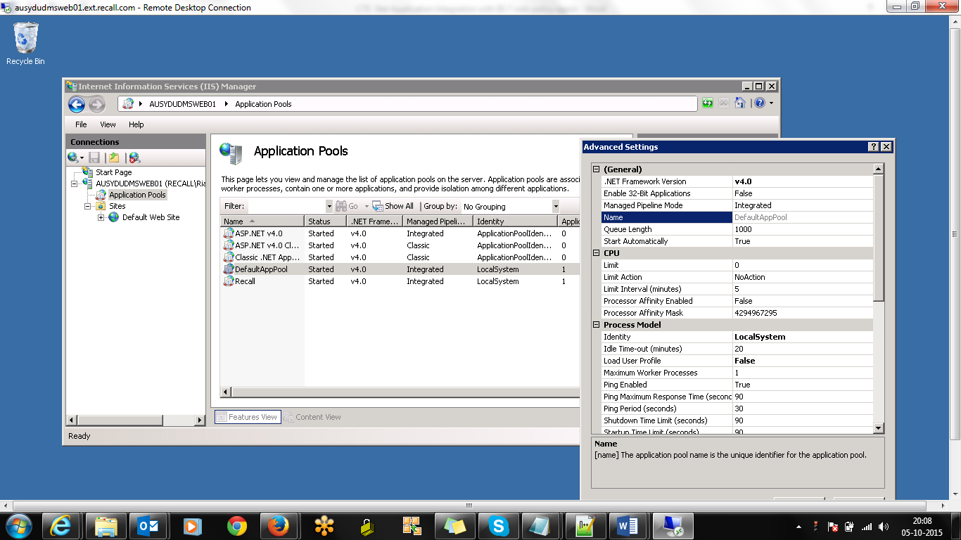

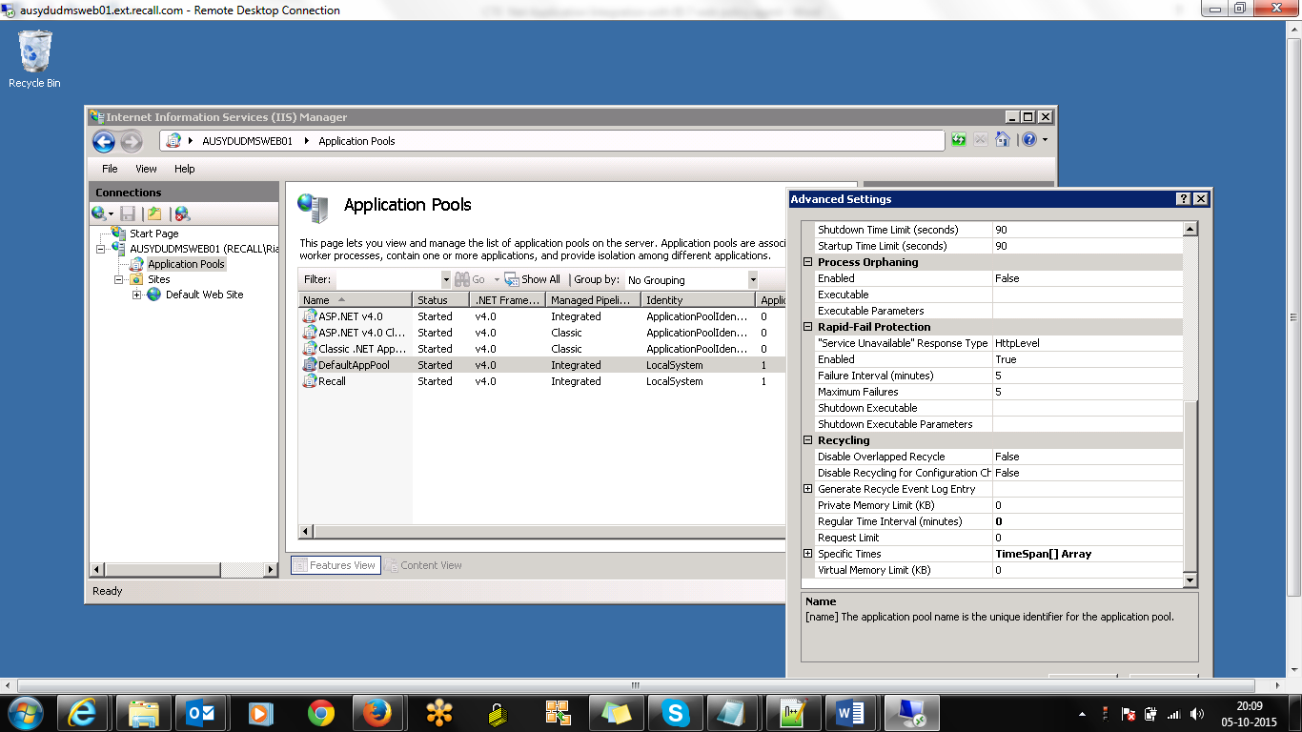

Also need following FR changes OpenSSOAgentConfiguration.properties file

com.forgerock.agents.nss.shutdown = off

Need to check for the setting in Openam console if the default 'centralized' configuration method then we should set this property in the Agent's console settings under the 'Miscellaneous' tab.  
To first check if it's 'centralized', look under the Agent's 'Global' tab for the option Location of Agent Configuration Repository.  
If, on the other hand, you are using 'local' then you can set the value in your OpenSSOAgentConfiguration.properties using '='.

com.sun.identity.agents.config.ignore.server.check = true

Restart IIS with iisreset

1. Now hit the application URL(Example: <http://agent.example.com:80>) : <https://requestweb1.am.recall.com:443>
2. It will redirected to the openam login page which we have integrated.
3. Enter the user credentials

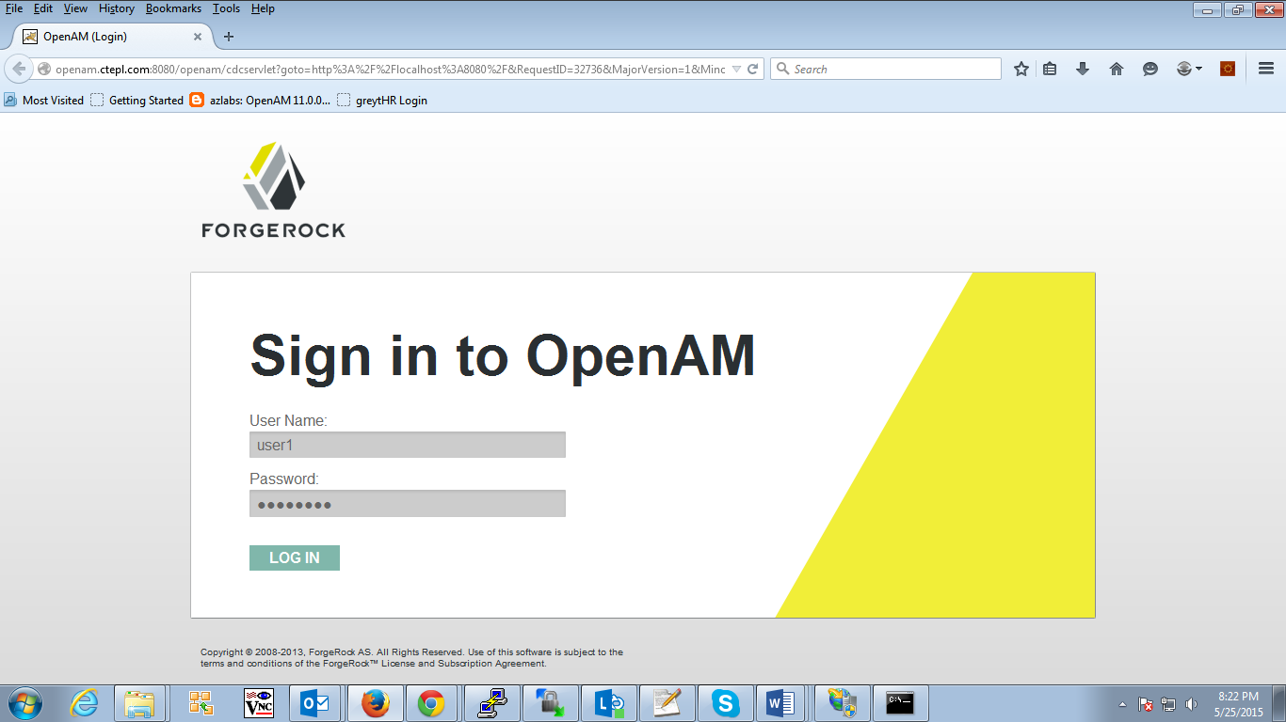

1. 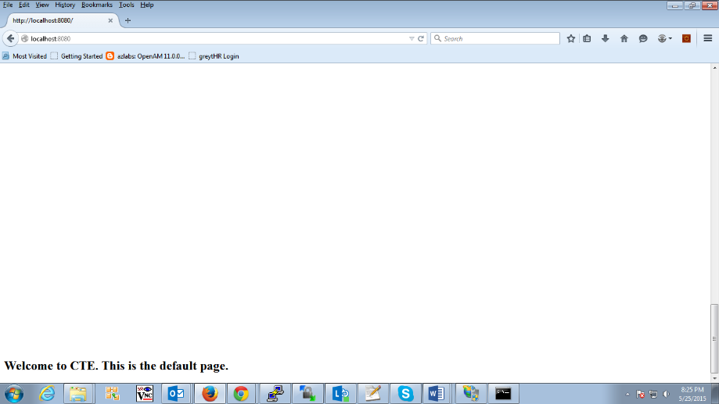
2. Now hit the default.aspx page to get the user profile attributes.

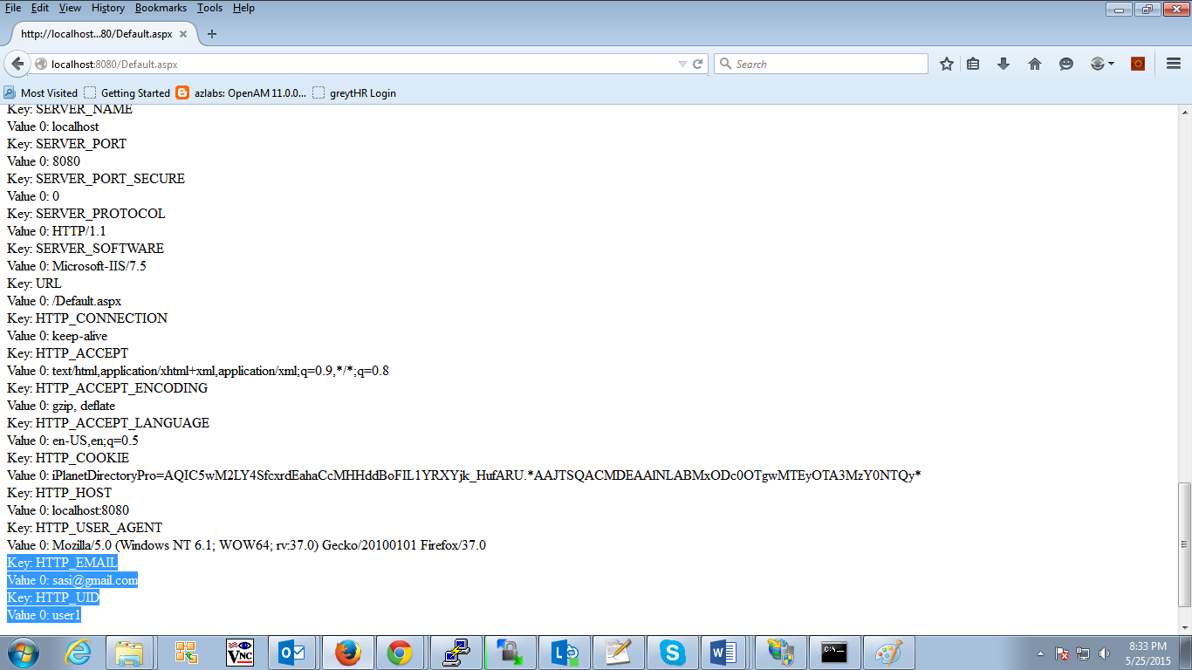

# To uninstall the agent

Log on the user with administrators privilages

Cd c:\IIS-v7-WINNT-64-Agent-3.3.3web_agents\iis7_agent\bin

Run : cscript IIS7Admin.vbs -unconfig config.txt